**JavaScript Assignments (Exercise :03)**

**Exercise JS-1**

Read a static array of 50 numbers and display the following output

1 is odd

2 is Even

3 is odd

4 is Even ………….

**Code:**

<!DOCTYPE html>

<html lang="en">

<head>

<meta charset="UTF-8">

<meta name="viewport" content="width=device-width, initial-scale=1.0">

<title>Print Even or odd from 1 to 50</title>

</head>

<body>

<h1>Print odd or even numbers from 1 to 50 :</h1>

<script>

var a = [];

for (var i = 1; i <= 50; i++) {

a[i] = i;

}

for (var i = 1; i <= 50; i++) {

if(a[i] % 2 == 1){

document.write(a[i] + " is odd");

document.write("<br>");

}

else{

document.write(a[i] + " is even");

document.write("<br>");

}

}

</script>

</body>

</html>

**OUTPUT:**

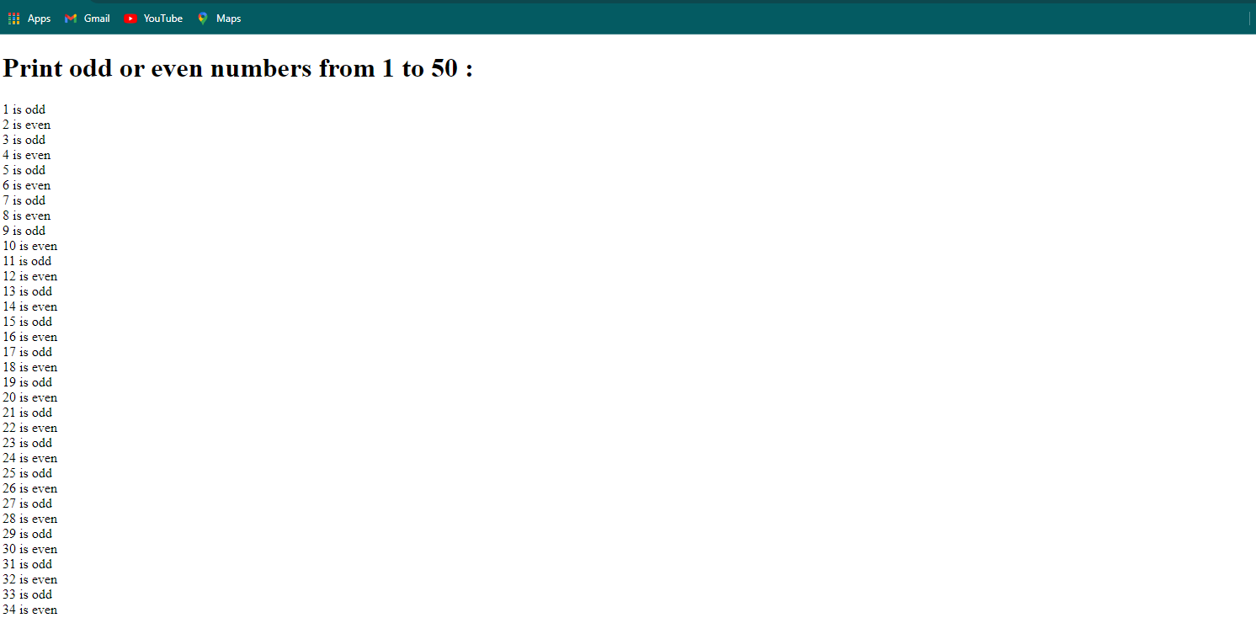

**Exercise JS-2**

The Number of words in a sentence, Number of Letters. Create a HTML textbox to accept the sentence:

"She sells sea shells on the sea shore"

**Code:**

<!DOCTYPE html>

<html lang="en">

<head>

<meta charset="UTF-8" />

<meta name="viewport" content="width=device-width, initial-scale=1.0" />

<title>Count the word and letter</title>

</head>

<body style="text-align: center">

<h1 style="color: rgb(11, 10, 15)">

Count The Number Of Words & Letters

</h1>

<input type="text" name="" id="inputField" />

<br /><br />

<button onclick="countWordsandLetters()">Submit</button>

<br /><br />

<p>Word Count: <span id="word">0</span></p>

<p>letters Count: <span id="letters">0</span></p>

<script>

function countWordsandLetters() {

var text = document.getElementById("inputField").value;

var countWords = text.match(/\w+/g).length;

var countLetter = 0;

for (var i = 0; i < text.length; i++) {

if (text[i] != "") {

countLetter++;

}

}

document.getElementById("word").innerHTML = countWords;

document.getElementById("letters").innerHTML = countLetter;

}

</script>

</body>

</html>

**OUTPUT:**

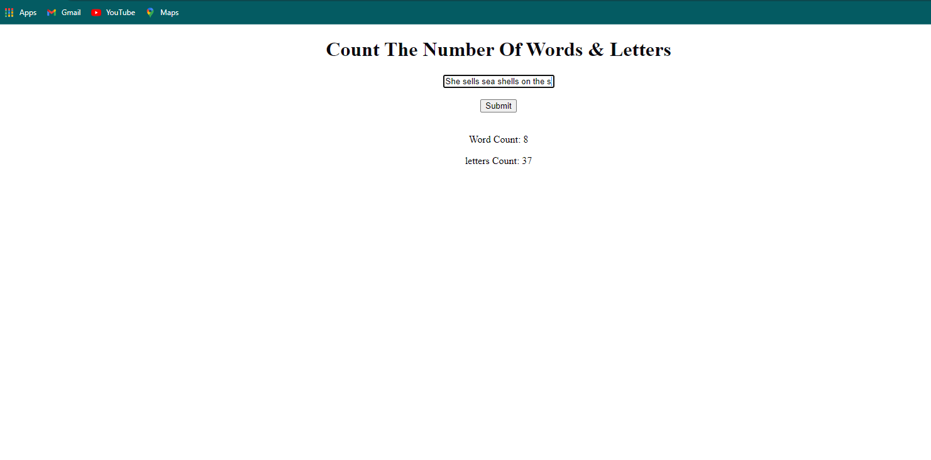

**Exercise JQ-1**

Build a Dynamic Grid using an array using JQuery. Use a Static array of "Employee Objects".

**Code:**

<!DOCTYPE html>

<html lang="en">

<head>

<meta charset="utf-8">

<meta name="viewport" content="width=device-width,initial-scale=1">

<title>Dynamic Grid</title>

<link rel="stylesheet" href="https://cdnjs.cloudflare.com/ajax/libs/jqueryui/1.11.4/themes/redmond/jquery-ui.min.css">

<link rel="stylesheet" href="https://cdnjs.cloudflare.com/ajax/libs/free-jqgrid/4.15.5/css/ui.jqgrid.min.css">

<script src="https://cdnjs.cloudflare.com/ajax/libs/jquery/1.12.4/jquery.min.js"></script>

<script src="https://cdnjs.cloudflare.com/ajax/libs/free-jqgrid/4.15.5/jquery.jqgrid.min.js"></script>

<script>

$(function () {

"use strict";

$("#grid").jqGrid({

colModel: [

{ name: "FirstName" },

{ name: "LastName" },

{ name: "Location"}

],

data: [

{ id: 1, FirstName: "Hemanth", LastName: "Kumar", Location: "Madanapalli" },

{ id: 2, FirstName: "Surya", LastName: "C", Location: " Chittor " },

{ id: 3, FirstName: "Dhoni", LastName: "MS", Location: "Ananthapuram" },

{ id: 4, FirstName: "Ruturaj", LastName: "Gaikwad", Location: "Tirupati" },

{ id: 5, FirstName: "Suresh", LastName: "Raina", Location: "Chennai" }

]

});

});

</script>

</head>

<h1>Employee Objects:</h1>

<body>

<table id="grid"></table>

</body>

</html>

**OUTPUT :**

